

Task T4.2

  - Reporting second-fifth PORTUGAL’s lab sessions

Views and opinions expressed are however those of the author(s) only and do not necessarily reflect those of the European Union or [name of the granting authority]. Neither the European Union nor the granting authority can be held responsible for them.



Organisations participating in the FITTER-EU co-creation path.
The following table provides detailed information on the organisation of the lab, including the number of participants and related logistical details.
Number of lab | Date | Venue | Facilitators | Total number of participants
1st in-presence lab | 07.11.2025 | Angra de Heroísmo, Terceira Island, Portugal | João Sarraipa;  André Rocha | 9
1st online lab | 14.11.2025 | Online | André Rocha | 7
2nd in-presence lab | 24.11.2025 | Angra de Heroísmo, Terceira Island, Portugal | André Rocha | 8
2nd online lab | 05.12.2025 | Online | André Rocha | 6
3rd in-presence lab | 11.12.2025 | Angra de Heroísmo, Terceira Island, Portugal | André Rocha | 4
Table 1: Logistic details of the lab sessions

List of participants
The information required regarding the total number of participants who attended the FITTER-EU labs, including their organisational affiliation, is presented in the table below.
Organisation name | Number of participants from the organisation, roles (job position) of participants and distribution by gender. | Focus on DGs/vulnerable population groups (yes/no. If yes, please detail | Focus on a sector (energy, transport, housing) | Type of organization and activity | Geograophic scope of the activity /local/regional (specify)/national | Policy maker (yes/no) | Participations in the lab session
 |  |  |  |  |  |  | 1st lab | 2nd (online) | 3rd lab | 4th (online) | 5th lab
Misericórdia Altares – Mercy Charity Institution | 1 | yes, children, seniors, people in need | housing | social care institution | national | no | X | X | X
Misericórdia da Praia – Mercy Charity Institution | 2 | yes, children, seniors, people in need | housing | social care institution | national | no | X | X | X | X
Lar D Pedro V – social solidarity institution | 1 | yes, senior population | housing | social care institution | regional | no |  |  | X | X | X
CCIAH – Chamber of Commerce and Industry of Angra do Heroísmo | 2 | no | no | chamber of commerce and industry | national | no | X | X | X | X | X
CMPV (City House – Praia da Vitória) | 4 | yes, families with economic needs | multi sectoral | social care institution | regional | yes | X | X | X | X | X
CMAH (City House – Angra do Heroísmo) | 2 | yes, multiple disadvantaged groups | multi sectoral | public authority | regional | yes | X | X | X | X | X
DR Obras Públicas – Regional Directorate for Public Works | 2 | yes, multiple disadvantaged groups | multi sectoral | public authority | regional | no | X | X
CAD – Disability Support Centre | 1 | yes, people with disabilities | housing | social care institution | regional | no |  | X | X | X
Table 2: List of organisations participating in the labs.

Sectoral focus
During the discussion sessions, participants naturally formed two working groups based on shared interests and affinities. Given the close relationship between the energy and housing sectors, each group was cross-sectoral, bringing together organisations operating across both areas. Consequently, discussions were not organised along sector-specific lines, but instead fostered integrated, cross-cutting exchanges that combined perspectives from both energy and housing stakeholders.
First in-presence lab
- List of organisations working in energy
- CCIAH – Chamber of Commerce and Industry of Angra do Heroísmo
- CMAH (City House – Angra do Heroísmo)
- DR Obras Públicas – Regional Directorate for Public Works
- CMPV (City House – Praia da Vitória)
- List of organisations working in housing or transport
- Misericórdia Altares – Mercy Charity Institution
- Misericórdia da Praia – Mercy Charity Institution
- CCIAH - Chamber of Commerce and Industry of Angra do Heroísmo
- CMPV (City House – Praia da Vitória)
- CMAH (City House – Angra do Heroísmo)
- DR Obras Públicas – Regional Directorate for Public Works
First online session
- List of organisations working in energy
- CCIAH – Chamber of Commerce and Industry of Angra do Heroísmo
- CMAH (City House – Angra do Heroísmo)
- DR Obras Públicas – Regional Directorate for Public Works
- CMPV (City House – Praia da Vitória)
- List of organisations working in housing or transport
- Misericórdia Altares – Mercy Charity Institution
- Misericórdia da Praia – Mercy Charity Institution
- CCIAH – Chamber of Commerce and Industry of Angra do Heroísmo
- CMPV (City House – Praia da Vitória)
- DR Obras Públicas – Regional Directorate for Public Works
- CMAH (City House – Angra do Heroísmo)
- CAD – Disability Support Centre
Second in-presence lab
- List of organisations working in energy
- CCIAH – Chamber of Commerce and Industry of Angra do Heroísmo
- CMAH (City House – Angra do Heroísmo)
- CMPV (City House – Praia da Vitória)
- List of organisations working in housing or transport
- Misericórdia Altares – Mercy Charity Institution
- Misericórdia da Praia – Mercy Charity Institution
- Lar D Pedro V – social solidarity institution
- CMPV (City House – Praia da Vitória)
- CAD – Disability Support Centre
- CMAH (City House – Angra do Heroísmo)
- CCIAH – Chamber of Commerce and Industry of Angra do Heroísmo
Second online session
- List of organisations working in energy
- CCIAH – Chamber of Commerce and Industry of Angra do Heroísmo
- CMAH (City House – Angra do Heroísmo)
- CMPV (City House – Praia da Vitória)
- List of organisations working in housing or transport
- Misericórdia da Praia – Mercy Charity Institution
- Lar D Pedro V – social solidarity institution
- CCIAH – Chamber of Commerce and Industry of Angra do Heroísmo
- CMPV (City House – Praia da Vitória)
- CMAH (City House – Angra do Heroísmo)
- CAD – Disability Support Centre
Third in-presence lab
- List of organisations working in energy
- CCIAH – Chamber of Commerce and Industry of Angra do Heroísmo
- CMAH (City House – Angra do Heroísmo)
- CMPV (City House – Praia da Vitória)
- List of organisations working in housing or transport
- Lar D Pedro V – social solidarity institution
- CCIAH – Chamber of Commerce and Industry of Angra do Heroísmo
- CMPV (City House – Praia da Vitória)
- CMAH (City House – Angra do Heroísmo)

Variations to the proposed co-creation methodology
The methodology and co-creation techniques initially defined were largely implemented as planned, with no major discrepancies identified during the execution of the sessions. The main adjustment concerned the integration of online sessions between the in-person workshops, which had not been part of the original planning. These online sessions were introduced to ensure continuity, consolidate outcomes from the preceding in-person sessions, and better prepare subsequent activities.
As a result, the process comprised three in-person sessions, complemented by two online sessions held in between. This adjustment allowed participants to reflect on preliminary results, validate emerging findings, and contribute asynchronously, thereby strengthening the overall quality and coherence of the co-creation outcomes. The core agenda and methodological approach of each session were maintained, with the online sessions acting as supportive and complementary moments rather than replacements.
Following the completion of the sessions, the project team plans to share the drafted reports with all participating actors for review and final feedback. This validation step is expected to take place over the coming weeks and aims to ensure accuracy, inclusiveness, and alignment with participants’ perspectives. Additionally, all contributors will be invited to the final project conference, to be held in Seville, Spain, where the collective results will be presented, and the relevance and societal value of participants’ contributions will be highlighted.
Finally, dissemination at regional level was supported by the Chamber of Commerce and Industry of Angra do Heroísmo (CCIAH), which assisted in promoting the workshops across the Azores and attracting a broader audience. To further reinforce visibility, a press communication was prepared alongside a promotional poster. This material is presented in Illustration 1 below.

Illustration 1: Poster used for the dissemination of the sessions

Co-created policy measures to reach a just transition
Building on the outcomes of the first in-person workshop, which identified a set of relevant policy measures in the energy and housing sectors, the subsequent activity concentrated on examining the key challenges faced by these sectors, with particular attention to the negative effects of the twin transition on vulnerable populations. Overall, participants did not identify substantial weaknesses in the existing policy framework that would require direct adaptation of the policies themselves. Instead, the central issue highlighted was the limited capacity of low-income households to effectively benefit from the available measures. In many cases, the main barrier is not policy design but the inability to meet upfront investment costs required for the adoption of new energy technologies or for housing recovery and renovation.
In the energy sector, despite what was stated above, one existing policy was identified as requiring potential adaptation, as further detailed later in this document. By contrast, discussions related to the housing sector revealed that the most critical bottleneck lies not in policy formulation but in systemic and institutional constraints, particularly the excessive duration of judicial and administrative procedures. Participants noted that housing-related legal resolutions—which ideally should be concluded within a timeframe of less than one year—can in practice take several years, in some cases extending up to a decade. This structural delay significantly undermines the effectiveness of policies aimed at rehabilitation, reconstruction, or improvement of housing conditions. While insufficient income remains a transversal and persistent constraint across all areas, the lack of institutional responsiveness further limits the capacity of existing measures to produce timely and meaningful outcomes. Consequently, the co-creation process focused primarily on the definition of new or complementary policy approaches designed to better reflect the shared vision emerging from the sessions and to address both financial and systemic barriers.
The next activity focused primarily on identifying the systemic changes required to achieve a just twin transition, in line with the shared vision presented during the sessions. Building on the outcomes of previous discussions, participants collectively reflected on the changes needed across key systemic dimensions—namely environment, society and culture, economy and finance, and science, technology and infrastructure. As a result, a set of temporal changes and policy orientations was defined, outlining both adjustments to existing policies and the introduction of new measures over short-, medium-, and long-term horizons, as illustrated in the figure below (Illustration 2).
To structure the identified systemic changes over time, participants defined a set of milestones for 2030, 2035, 2040, and 2045, reflecting progressive steps towards the shared Vision 2050. In the description below, E refers to energy-related measures, H to housing-related measures, EH to measures addressing both sectors, while E* denotes transversal actions applicable across multiple policy proposals detailed in the following chapter. The numerical identifiers correspond to specific policy propositions further elaborated later in this report.
By 2030, the focus is placed on creating the enabling social and infrastructural conditions for a just twin transition. Key priorities include increasing public awareness and education on the benefits of renewable energy and improving existing support schemes. At the same time, emphasis is placed on social inclusion through accessible public spaces (H1) and adapted public transport systems (E2). These actions are complemented by support for the digital and green transformation of public spaces and transport infrastructure, promoting adaptable, low-emission, and carbon-free mobility solutions.
By 2035, the systemic changes advance towards stronger economic, regulatory, and capacity-building measures. This phase prioritises the rehabilitation of sustainable roads (E4) and the introduction of financial incentives, including a 0% VAT policy for the purchase of materials (EH1) and tax benefits for the acquisition of equipment (EH1). Social measures are reinforced through training and support in financial literacy, household management, social housing, and temporary housing solutions (H2). In parallel, direct financial support to suppliers (E*) is introduced to enable the installation of solar panels for low-income and vulnerable households, alongside neighbourhood rehabilitation initiatives (H2) offering direct, person-centred support to residents.
By 2040, the transition moves towards deeper structural and sector-specific transformations. Recognising agriculture as a key sector, participants highlighted the importance of agrivoltaic solutions (E3), allowing solar panels to support agricultural machinery while preserving productive land use. At system level, the deployment of energy storage battery infrastructure by public authorities (E*) is envisaged to strengthen energy resilience. A key social milestone is also defined: by 2040, all social housing units should be powered by renewable energy sources (E*), ensuring long-term sustainability and affordability.
By 2045, the focus shifts to the consolidation and scaling of advanced energy and infrastructure solutions. This includes support for the installation and construction of solar panels for agricultural purposes (E3), reinforcing the integration of renewable energy into primary production systems. In parallel, a transformative infrastructure objective is defined through the conversion of asphalt roads into vehicle-rechargeable pavements (E4), enabling new forms of sustainable mobility and energy interaction within the transport system.
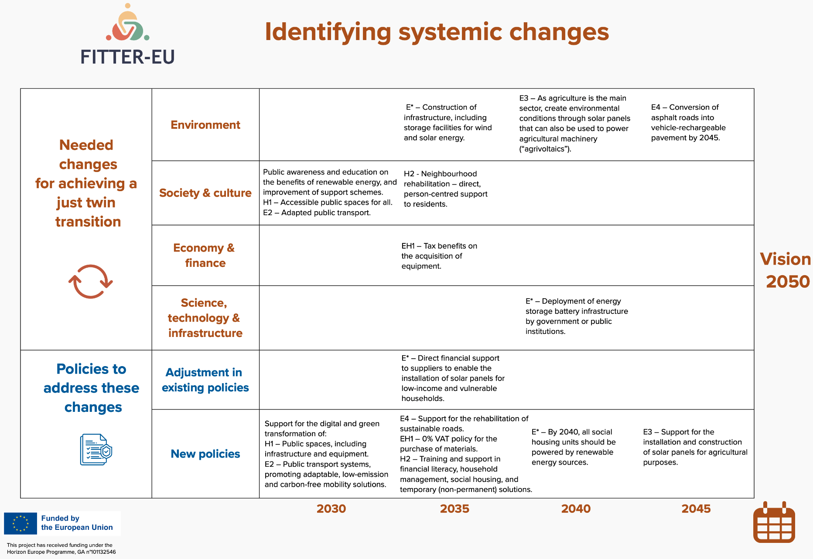
Illustration 2: Systemic changes identified to follow the vision
The next two tables present the sectoral challenges and negative effects of the twin transition identified for the energy and housing sectors, together with the policy responses proposed to address them. For each prioritised challenge or negative effect, the tables introduce the corresponding policies—either newly proposed or adapted—developed in line with the shared vision described above and aimed at supporting a more just twin transition.
By way of example, to address the challenge of “worsening financial vulnerability” in the energy sector (Table 4), the adaptation of the existing policy E1 is proposed, alongside the creation of new policies identified by the acronyms E2, E3, and EH2. The full titles and descriptions of these policy adaptations and new proposals can be found in the following sub-sections of this chapter, where all measures are presented in detail.
Sectoral challenge/negative effects identified in each sector | Adjustments of existing policies | New policy proposals
Worsening financial vulnerability | E1 | E2; E3; EH2
Exclusion through regulations | - | -
Unequal access to infrastructure and reliable services | E1 | E2; E4; EH2
Table 3: Final list of policy proposals and sectoral transition challenges – Energy sector
Sectoral challenge/negative effects identified in each sector | Adjustments of existing policies | New policy proposals
Worsening financial vulnerability | - | H2; EH1; EH2
Exclusion through regulations | - | H2
Unequal access to infrastructure and reliable services | - | H1
Increase of the health burden | - | EH1; EH2
Table 4: Final list of policy proposals and sectoral transition challenges – Housing sector
Following the identification of policy measures to be created or adapted in response to the negative effects of the twin transition, the next phase focused on assessing the capacity of these policies to effectively respond to the challenges identified. This analysis examined how each proposed policy addresses its corresponding challenge, taking into account not only the overarching negative impact but also the more specific and detailed effects associated with it. In this context, the discussion explored the extent to which each policy measure could mitigate, prevent, or counteract the identified problems, thereby clarifying its capacity of response in relation to the affected sector and target groups.
To support this assessment, participants engaged in a structured prioritisation exercise, guided by the facilitator. The proposed changes were first clustered and narrowed down, ensuring that at least one policy response was retained for each identified negative impact. Participants then individually prioritised the most relevant changes through a voting process, leading to the collective selection of a limited set of priority measures. Finally, cause–effect relationships between the selected policies were analysed, with particular attention to their temporal sequencing. Starting from measures closest to the present time horizon (2030), participants mapped how certain changes enable or depend on others, both across sectors and systemic dimensions, thus providing a coherent basis for evaluating the responsiveness and interdependence of the proposed policy measures.
The next two tables present the results of the analysis carried out to classify the adequacy and capacity of response of each proposed policy across the different sectors—energy, housing, and mixed measures. This assessment reflects how effectively each policy is expected to address the identified challenges and negative effects associated with the twin transition.
By way of example, in the table 5 (just bellow) related to the energy sector, the policy identified by the acronym EH1 (Zero VAT on Energy-Efficient Equipment) is assigned a capacity-of-response score of 2 on a scale from 1 to 5 with respect to the challenge of increasing heating-related costs. This score reflects the fact that the policy reduces upfront costs for households by introducing a 0% VAT rate on domestic energy-efficient equipment, thereby improving affordability and facilitating access to more efficient technologies. While this measure can contribute to lowering long-term energy consumption and associated heating expenses, its impact is considered moderate, as it does not directly address energy prices or household income constraints. Its effectiveness therefore depends on sufficient fiscal capacity, strong coordination between tax and energy policy frameworks, and complementary measures—particularly for low-income and vulnerable households.
Macro areas | Policy measures | Responsiveness capacity  (1 - 5)  Include the number of voters in each number per policy |  |  |  |  | Negative impacts | Policy measures | Responsiveness capacity  (1 - 5)  For each policy measure, include the number of voters that selected each number
Macro areas | Policy measures | 1 | 2 | 3 | 4 | 5 |  | Policy measures | 1 | 2 | 3 | 4 | 5
Worsening financial vulnerability | E3 | X |  |  |  |  | Higher electricity bills | E4 |  | X
 |  |  |  |  |  |  |  | E3 |  |  | X
 |  |  |  |  |  |  |  | E1 |  |  |  | X
 |  |  |  |  |  |  |  | EH2 |  |  |  | X
Worsening financial vulnerability | E2 |  |  | X |  |  | Increased heating costs | E3 |  | X
 |  |  |  |  |  |  |  | EH1 |  | X
 |  |  |  |  |  |  |  | E1 |  | X
 |  |  |  |  |  |  |  | EH2 |  | X
Worsening financial vulnerability | E1  EH2 |  |  | X  X |  |  | Exposure to energy poverty | E4 |  | X
 |  |  |  |  |  |  |  | E1 |  | X
 |  |  |  |  |  |  |  | EH2 |  | X
Worsening financial vulnerability |  |  |  |  |  |  | Loss of property- resale value | EH1 |  |  |  | X
 |  |  |  |  |  |  |  | E1 |  |  | X
 |  |  |  |  |  |  |  | EH2 |  |  | X
Worsening financial vulnerability |  |  |  |  |  |  | Lose income due to the production of solar energy
Exclusion through regulations |  |  |  |  |  |  | Penalties for not retrofitting
Unequal access to infrastructure and reliable services | E4 |  |  | X |  |  | More frequent power outages
Unequal access to infrastructure and reliable services | E2 |  |  |  | X
Unequal access to infrastructure and reliable services | E1 |  |  | X
Unequal access to infrastructure and reliable services | EH2 |  |  | X
Other negative effects |  |  |  |  |  |  | Other negative effects

Table 5: Responsiveness Capacity of the proposed policies in the Energy sector
Macro areas | Policy measures | Responsiveness capacity  (1 - 5) |  |  |  |  | Negative impacts | Policy measures | Responsiveness capacity  (1 - 5)
Macro areas | Policy measures | 1 | 2 | 3 | 4 | 5 | Negative impacts | Policy measures | 1 | 2 | 3 | 4 | 5
Worsening financial vulnerability | H2 |  |  | X |  |  | Higher electricity bills | EH1 |  |  | X
Worsening financial vulnerability | EH1 |  | X |  |  |  | Increased heating costs | EH1 |  | X
Worsening financial vulnerability | EH2 |  | X |  |  |  | Exposure to energy poverty
Worsening financial vulnerability |  |  |  |  |  |  | Loss of property- resale value
Worsening financial vulnerability |  |  |  |  |  |  | Lose income due to the production of solar energy
Worsening financial vulnerability |  |  |  |  |  |  | Higher house insurance costs
Exclusion through regulations | H2 |  |  |  |  | X | Penalties for not retrofitting | H1 |  |  |  | X
Exclusion through regulations |  |  |  |  |  |  | Bans on selling/renting inefficient homes
Unequal access to infrastructure and reliable services | H1 |  |  |  | X |  | More frequent power outages
Unequal access to infrastructure and reliable services |  |  |  |  |  |  | Presence of damp or mold in the house | EH1 |  |  | X
 |  |  |  |  |  |  |  | EH2 |  |  | X
Unequal access to infrastructure and reliable services |  |  |  |  |  |  | More risked perceived by insurance companies of the house with no renovation or retrofitting
Unequal access to infrastructure and reliable services |  |  |  |  |  |  | Stronger effects of extreme weather events
Increase of the health burden |  |  |  |  |  |  | Diseases and health problems caused by cold, damp indoor conditions | EH1 |  |  |  | X
 |  |  |  |  |  |  |  | EH2 |  |  |  | X
Other negative effects |  |  |  |  |  |  | Other negative effects

Table 6: Responsiveness Capacity of the proposed policies in the Housing sector

Following the analysis of the proposed policies and their respective capacity of response, the initial list of measures was further refined and adjusted, resulting in a consolidated set of policy proposals. This final set includes both new policy proposals and one adapted existing policy, as discussed earlier. The outcomes of this process are presented in the form of policy factsheets, which are detailed in the following subsections 3.1, 3.2, and 3.3. Each policy was developed using a common factsheet template, with one factsheet per policy, allowing the identification of objectives, implementation mechanisms, and target populations.
It should be noted that most of the proposed policies are designed to address the general population, and a detailed analysis of gender or other population-specific dimensions was not carried out at this stage. Instead, the relevant considerations regarding target groups and inclusiveness are reflected in the information explicitly defined within each policy factsheet. The development of the factsheets was supported by group discussions and brainstorming activities, using post-its to collectively complete all sections of the templates and ensure consistency across the proposals.

Energy policies

POLICY FACTSHEETS TO ADAPT EXISTING POLICIES
Section | Guiding questions / What to fill in
Acronym of the policy | E1
Title of the policy (existing) | SOLENERGE
Sectoral focus | Energy
Original policy objectives | Provide financial support for the acquisition and installation of photovoltaic solar panels, covering up to 100% of eligible costs, with a maximum support of €1,500.
Prioritised challenge addressed | Improve access to renewable energy solutions by reducing upfront financial barriers through direct support via certified suppliers, advance payments, and coverage of a percentage of eligible costs.
Limitations or gaps | Low-income and vulnerable households face difficulties accessing the scheme due to the need to pre-finance installation costs before reimbursement, leading to exclusion of those without sufficient liquidity.
Proposed adaptations | Introduce upfront payment mechanisms and direct supplier payments to eliminate pre-financing requirements for beneficiaries, expand eligibility criteria, and simplify administrative procedures.
Policy type(s) | Economic incentives (subsidies and financial support schemes).
Participatory dimension & stakeholders | Local authorities, energy agencies, certified installers, and community organizations should be involved in the adaptation process.
Target population: | General population, with a particular focus on low-income and energy-vulnerable households.
Systemic focus | Environment (renewable energy transition) and society (energy affordability and social inclusion).
Potential risks/barriers | Limited availability of community or regional funding ceilings may restrict the scale of implementation.
Drivers/enablers | European Union funding frameworks, and support from the Government of the Azores and the Government of Portugal.
Time horizon | Medium to long term, with full implementation targeted by 2035.
Feasibility & resources | Adequate financial allocations, institutional coordination, and streamlined administrative and payment systems are required.
Table 7: E1 policy factsheet

POLICY FACTSHEETS FOR NEW POLICY PROPOSALS

Section | Guiding questions / What to fill in
Acronym of the policy | E2
Title of the policy (new proposal) | Accessible Zero-Emission Public Transport for All
Sectoral focus | Energy
Prioritised challenge addressed | Lack of accessible and electric public transport solutions.
Policy description | Ensure that each municipality has at least one zero-emission and fully accessible bus, taxi, and minibus, supporting inclusive mobility and emissions reduction.
Policy type(s) | Public services (infrastructure and service provision).
Participatory dimension & stakeholders | Private sector operators, civil society organisations, and local authorities.
Target population: | People with disabilities, both residents and visitors.
Systemic focus | Environment, society & culture, economy & finance, science/technology/infrastructure, and policy/governance.
Potential risks/barriers | Political resistance, funding limitations, and technological constraints.
Drivers/enablers | Existing funding programmes and strong social demand.
Time horizon | Long term (by 2035).
Feasibility & resources | Financial investment and access to zero-emission transport technologies.
Table 8: E2 policy factsheet

Section | Guiding questions / What to fill in
Acronym of the policy | E3
Title of the policy (new proposal) | Agrivoltaics Azores
Sectoral focus | Energy and agriculture.
Prioritised challenge addressed | Sustainable agricultural production combined with renewable energy generation.
Policy description | Reduce the agricultural sector’s energy footprint through non-repayable financial support for equipment and integrated digital and sustainable technologies.
Policy type(s) | Economic incentives (subsidies and grants) and public programmes.
Participatory dimension & stakeholders | Private agricultural stakeholders and local authorities.
Target population: | Agricultural private sector.
Systemic focus | Environment and economy & finance.
Potential risks/barriers | Limited awareness of benefits, investment reluctance, and competing priorities.
Drivers/enablers | Regional government support and existing energy programmes.
Time horizon | Long term (by 2045).
Feasibility & resources | Dedicated financial ceilings and institutional coordination.
Table 9: E3 policy factsheet

Section | Guiding questions / What to fill in
Acronym of the policy | E4
Title of the policy (new proposal) | The New Roads
Sectoral focus | Energy and transport infrastructure.
Prioritised challenge addressed | Energy-efficient and low-emission road infrastructure.
Policy description | Promote sustainable road requalification by reducing polluting elements and integrating clean energy production and electric vehicle charging infrastructure.
Policy type(s) | Public services (infrastructure investment).
Participatory dimension & stakeholders | Private infrastructure providers and local authorities.
Target population: | General population.
Systemic focus | Environment; economy & finance; science/technology/infrastructure; and policy/governance.
Potential risks/barriers | Funding gaps and limited access to advanced technologies.
Drivers/enablers | European funding instruments and available clean technologies.
Time horizon | Medium to long term (2035–2045).
Feasibility & resources | European financing and access to innovative infrastructure technologies.
Table 10: E4 policy factsheet

Housing policies

POLICY FACTSHEETS FOR NEW POLICY PROPOSALS

Section | Guiding questions / What to fill in
Acronym of the policy | H1
Title of the policy (new proposal) | Accessible Public Spaces
Sectoral focus | Housing and public infrastructure.
Prioritised challenge addressed | Lack of accessible infrastructure and public equipment for all users, including people with reduced mobility and visual impairments.
Policy description | This policy promotes universal access to public spaces by ensuring mobility-friendly infrastructure and adapted access systems, enabling equal use of public facilities.
Policy type(s) | Public services (investment in accessible infrastructure).
Participatory dimension & stakeholders | Local authorities and civil society organisations.
Target population: | General population, including people with disabilities.
Systemic focus | Society & culture and science/technology/infrastructure.
Potential risks/barriers | Political resistance and funding gaps.
Drivers/enablers | European support programmes and availability of enabling technologies.
Time horizon | Medium term (by 2030).
Feasibility & resources | Requires financial resources, institutional coordination, and accessible technology solutions.
Table 11: H1 policy factsheet

Section | Guiding questions / What to fill in
Acronym of the policy | H2
Title of the policy (new proposal) | Integrated Neighbourhoods
Sectoral focus | Housing and social inclusion.
Prioritised challenge addressed | Social stigma and exclusion of residents in social housing, and the need to reposition social housing as a temporary and enabling solution.
Policy description | The policy provides direct support and shared responsibility with residents, combined with training across multiple areas, to prepare households for a transition towards personal and family independence beyond social housing.
Policy type(s) | Public services and information/training programmes.
Participatory dimension & stakeholders | Civil society organisations and local authorities.
Target population: | Residents of social housing and the wider community.
Systemic focus | Environment, society & culture, economy & finance, science/technology/infrastructure, and policy/governance.
Potential risks/barriers | Political resistance, low tenant incomes affecting transition capacity, and limited access to technology.
Drivers/enablers | Strong rental market availability and network-based cooperation among stakeholders.
Time horizon | Medium to long term (by 2035).
Feasibility & resources | Requires sufficient housing supply and strong institutional capacity.
Table 12: H2 policy factsheet

Both Energy and Housing policies

POLICY FACTSHEETS FOR NEW POLICY PROPOSALS

Section | Guiding questions / What to fill in
Acronym of the policy | EH1
Title of the policy (new proposal) | Zero VAT on Energy-Efficient Equipment
Sectoral focus | Energy and housing.
Prioritised challenge addressed | Improving affordability and access to energy-efficient household equipment.
Policy description | This policy introduces a 0% VAT rate on the purchase of domestic energy-efficiency equipment, reducing upfront costs and accelerating the adoption of more efficient technologies in households.
Policy type(s) | Economic incentives (tax reduction and subsidies).
Participatory dimension & stakeholders | Local authorities as policy promoters, in coordination with regional and national fiscal authorities.
Target population: | General population.
Systemic focus | Environment, society & culture, and economy & finance.
Potential risks/barriers | Negative short-term impact on regional public finances.
Drivers/enablers | Support from local government and strong consumer demand for efficient technologies.
Time horizon | Medium to long term (by 2035).
Feasibility & resources | Requires sufficient fiscal capacity and coordination between tax and energy policy frameworks.
Table 13: EH1 policy factsheet

Section | Guiding questions / What to fill in
Acronym of the policy | EH2
Title of the policy (new proposal) | Renewable Neighbourhoods
Sectoral focus | Energy and housing.
Prioritised challenge addressed | Limited access to renewable energy solutions for financially disadvantaged households.
Policy description | The policy supports the acquisition and installation of domestic renewable energy systems in social housing neighbourhoods, ensuring equitable access to clean energy and reducing energy poverty.
Policy type(s) | Public services (investment programmes in renewable energy infrastructure).
Participatory dimension & stakeholders | Local authorities as implementing bodies, with support from regional public administrations.
Target population: | Low-income households and residents of social housing.
Systemic focus | Environment and society & culture.
Potential risks/barriers | Limited financial ceilings and budget constraints.
Drivers/enablers | European structural programmes and availability of mature renewable energy technologies.
Time horizon | Long term (by 2040).
Feasibility & resources | Requires dedicated structural funds for municipalities and strong institutional capacity at local and regional levels.
Table 14: EH2 policy factsheet

Transformative potential of policies
This chapter assesses the transformative potential of the proposed policy measures, building on the policy identification and refinement work presented in the previous sections. The objective of this analysis was to go beyond the immediate capacity of each policy to address a specific challenge and to evaluate its potential to trigger deeper, systemic change in the context of a just twin transition. In particular, the analysis aimed to understand whether the proposed measures can contribute not only to short-term problem-solving but also to longer-term transformations in institutional arrangements, social practices, and equity outcomes.
To this end, each policy was analysed against a set of guiding questions covering two main dimensions: impact and feasibility and implementation. The impact analysis examined whether a policy directly addresses a sectoral challenge, generates wider systemic effects across multiple domains, reshapes existing rules or institutional frameworks, influences dominant paradigms or political priorities, and contributes to reducing inequalities associated with the green and digital transition. In parallel, feasibility considerations focused on identifying potential political, cultural, or financial barriers, as well as assessing whether the policy can be implemented immediately or requires additional preparatory steps.
The results of this analysis are presented in the following table (Table 15), where each proposed policy is assessed against the above criteria. By way of illustration, policy E2 (Accessible Zero-Emission Public Transport for All) was identified as directly addressing a concrete sectoral challenge—namely the lack of accessible and zero-emission public transport—while also generating broader systemic effects, particularly in the domains of society and culture through improved inclusion and mobility. The policy has the potential to influence institutional regulations related to public service provision, although it does not fundamentally alter prevailing policy paradigms. Importantly, it contributes to reducing inequalities in the transition by targeting people with disabilities and promoting inclusive access to sustainable mobility. This combination of impacts is reflected in its high transformative potential score (4 out of 5). At the same time, E2 also achieved a high feasibility score (4 out of 5), as it can be implemented in the short term using existing funding programmes and responding to strong social demand, with financial constraints identified as the main implementation barrier.
In the subsequent task, the proposed policies were scored and positioned according to their transformative potential and feasibility of implementation, allowing for a comparative and strategic overview of the policy portfolio. As illustrated in the following figure, each policy was placed on a two-axis graph, where the X-axis represents feasibility—ranging from low to high and encompassing political, cultural, financial, and technical ease of implementation—and the Y-axis represents transformative potential, reflecting the ability of each policy to shift systems, reduce inequalities, and contribute meaningfully to the twin transition.
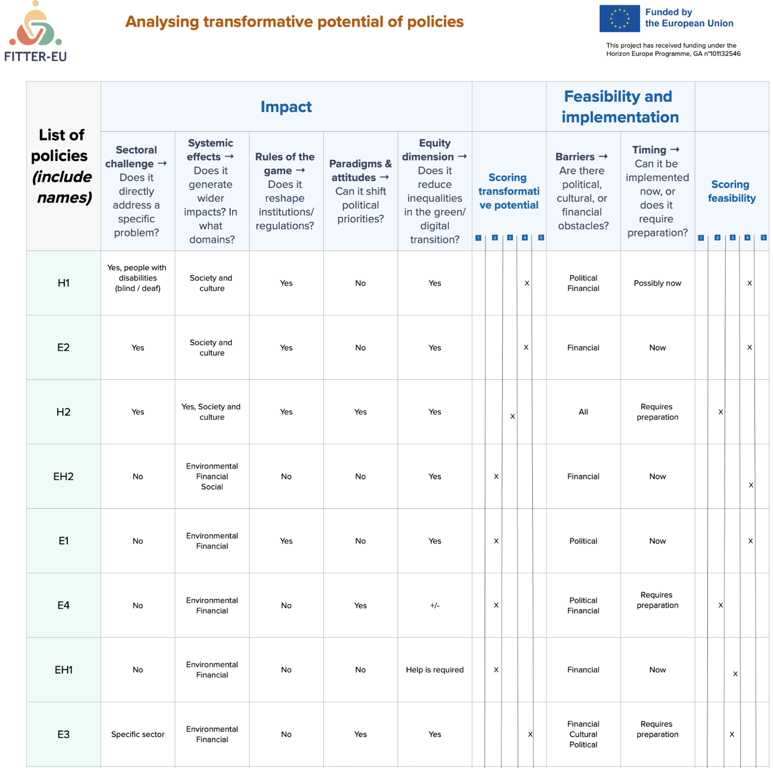
Table 15: Analysis of the policies’ transformative potential
Based on their positioning, policies were grouped into analytical quadrants, including Quick Wins, Transformative Bets, Short-term Stabilisers, Structural Shifts, and Non-starters. This categorisation supports strategic decision-making by distinguishing measures that can deliver immediate impact from those requiring longer-term commitment or deeper systemic change. By way of example, policy E2 (Accessible Zero-Emission Public Transport for All) was positioned within the “Quick Wins” quadrant, combining high feasibility with medium-to-high transformative potential. This reflects its relative ease of implementation using existing funding mechanisms, broad social acceptance, and clear societal benefits, particularly in terms of inclusive mobility and emissions reduction. As such, E2 can be considered a “low-hanging fruit” policy—capable of delivering tangible progress in the short term while contributing to the broader objectives of a just twin transition.
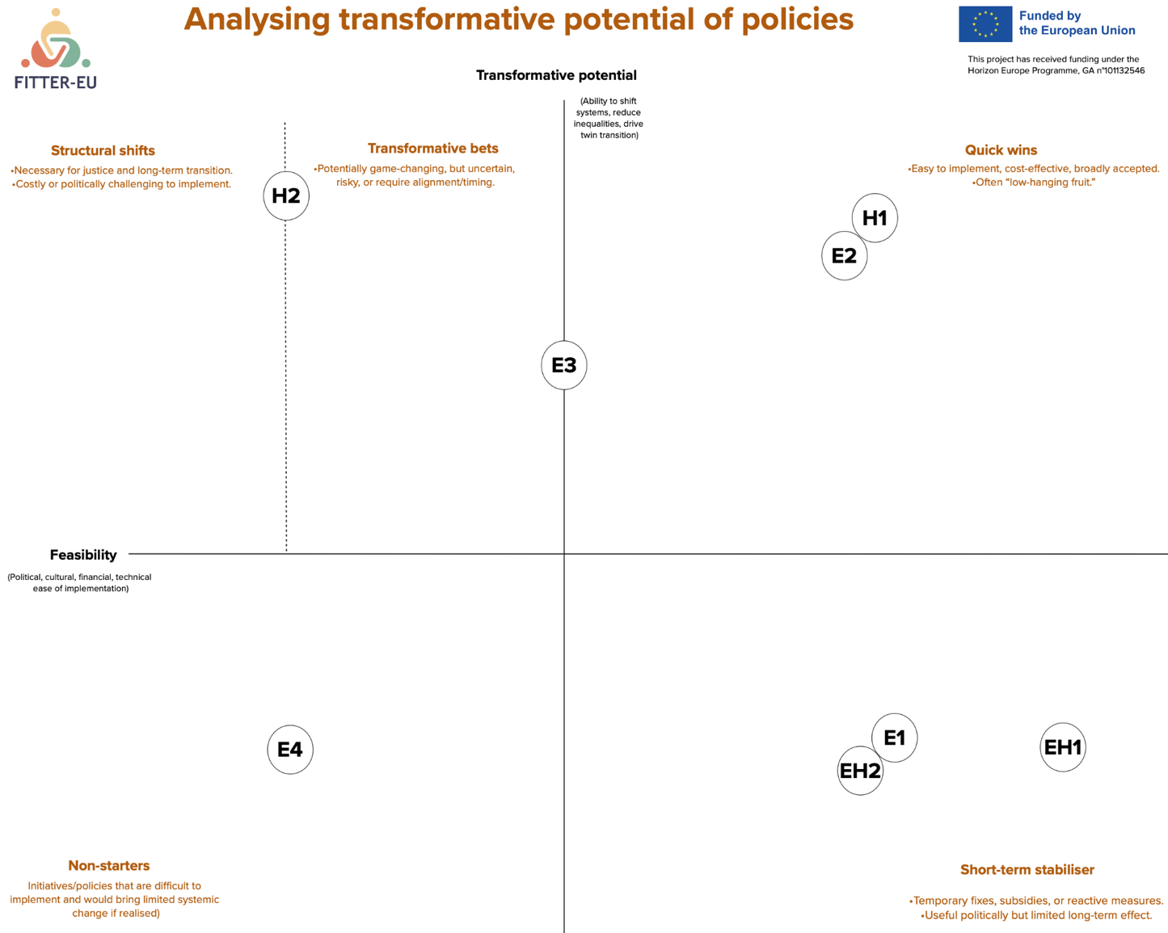
Illustration 3: Graph of the transformative potential of the proposed policies

Report the results of the agenda slot 12:15-12:45 Scoring the policies as transformative of the third lab (see slides 48-50 of the methodological guidelines (Guidelines 2nd set v6 26-11-25.pptx as a reference). On Table 3, for each policy proposal, report the following:
- The total number of votes received for each score (1–5);
- The policy category assigned by the group — quick wins, transformative bets, short-term stabilisers, structural shifts, or non-starters;
- The reasons behind this categorisation, to be detailed in the last column. Consider the different elements provided in the template for the discussion:
- Impact
- Systemic effects → Does it generate wider impacts? In what domains?
- Rules of the game → Does it reshape institutions/regulations?
- Paradigms & attitudes → Can it shift political priorities?
- Equity dimension → Does it reduce inequalities in the green/digital transition?
- Feasibility
- Barriers → Are there political, cultural, or financial obstacles?
- Timing → Can it be implemented now, or does it require preparation?
Be as detailed as possible when explaining the rationale for each classification.
Policies | Scoring the transformative potential |  |  |  |  | Scoring feasibility (in each number fill the number of votes) |  |  |  |  | Policy category (name the category) | Detail why the group classified the policy as such
Policies | 1 | 2 | 3 | 4 | 5 | 1 | 2 | 3 | 4 | 5 | Policy category (name the category) | Detail why the group classified the policy as such
Policy 1
Policy 2
Policy 4
…
Table 4: Scoring of policy proposals according to their transformative potential

Feedback on the co-creation methodology
This section provides an assessment of the co-creation methodology used in the lab sessions, highlighting strengths, challenges, and areas for improvement as identified by participants and facilitators.
Regarding stakeholder engagement:
Overall, no major challenges were encountered in terms of stakeholder engagement during the lab sessions. This was largely due to the highly engaged and close-knit nature of the local community, characteristic of an island context. Stakeholders demonstrated a strong willingness to participate, contribute, and be heard, and they valued recognition of their inputs and the assurance that their contributions were actively considered in the process. This sense of visibility and acknowledgement proved to be a strong intrinsic motivator for engagement throughout the labs.
To support stakeholder participation, the organising team implemented a proactive engagement strategy, clearly communicating the relevance of the labs and the value of stakeholder contributions. This approach proved particularly effective in the Azores context. Based on previous experience, the same strategy would likely have produced more limited results in larger continental urban areas, where stakeholders tend to have tighter schedules and lower availability to engage in participatory processes. The contrast highlights the importance of adapting engagement strategies to local social and territorial contexts.
Regarding the methodology of the co-creation path:
From a methodological perspective, the use of visual tools such as murals and diagrams was particularly effective. These elements helped establish clear milestones and provided participants and facilitators with a shared understanding of progress, making it easier to assess whether the discussions were aligned with the intended objectives. Compared to purely discussion-based approaches, these tools offered a more concrete structure and facilitated the consolidation of results.
The most challenging aspect of the methodology was related to fully understanding the underlying goal and logic of each methodological step, particularly in the initial phases. Clearer and more concise guidance would have been beneficial, ideally in the form of short, one-sentence instructions for each step, along with a more explicit sequencing or quantification of the methodological stages. Additionally, the inclusion of specific (but not excessive) predefined fields within each mural or diagram—indicating exactly what facilitators should record from the discussions—would have helped ensure that all required information was consistently captured.
As a suggestion for improvement, the methodology could benefit from a single, concise instruction sheet (e.g. a one-page leaflet) designed both for facilitators and participants. This document would summarise the purpose of each step and clarify expectations in a simple and accessible manner. As observed during the labs, if the methodology cannot be clearly explained within a very short time frame (e.g. one minute), it risks being perceived as overly complex.
Feedback by participants
According to feedback collected through the observations during the sessions, the most valued aspectsof the labs were the dynamic nature of the activities and the opportunity for active participation. Participants expressed strong interest not only in contributing but also in understanding the outcomes of the process. Their motivation and willingness to engage were seen as critical factors for the success of the labs; without this level of commitment, conducting the sessions would have been considerably more challenging.
One aspect that was not fully understood—particularly during the initial stages—was the relationship between the policy measures identified at the end of the first in-person lab and the challenges and vision elements discussed in subsequent sessions, especially during the second in-person meeting. At the time of implementation, it was not immediately clear how these elements interconnected within the overall methodology or what role they played across different stages of the process. However, this understanding appeared to improve progressively as the labs advanced and the methodology unfolded over time.

